**BÁO CÁO HỆ THỐNG PHÂN TÁN**

**GIAI ĐOẠN 3 (11/7-13/7)**

**NHÓM 15**

**TÌM HIỂU VỀ JSON TRÊN PYTHON**

1. **Cài đặt Tornado**
2. **Tornado là gì?**

**Tornado** is a scalable, [non-blocking](https://en.wikipedia.org/wiki/Asynchronous_IO) [web server](https://en.wikipedia.org/wiki/Web_server) and [web application framework](https://en.wikipedia.org/wiki/Web_application_framework) written in [Python](https://en.wikipedia.org/wiki/Python_(programming_language)). It was developed for use by [FriendFeed](https://en.wikipedia.org/wiki/FriendFeed); the company was acquired by [Facebook](https://en.wikipedia.org/wiki/Facebook) in 2009 and Tornado was [open-sourced](https://en.wikipedia.org/wiki/Open-sourcing) soon after.

**Cài đặt Tornado:**

Download Tornada ở <http://www.tornadoweb.org/en/stable/> file name [tornado-4.5.2.tar.gz](https://pypi.python.org/packages/fa/14/52e2072197dd0e63589e875ebf5984c91a027121262aa08f71a49b958359/tornado-4.5.2.tar.gz#md5=ab41f6765d58089f30ba51e8ec084a7b) ([md5](https://pypi.python.org/pypi?:action=show_md5&digest=ab41f6765d58089f30ba51e8ec084a7b))

Khi đã tải xong. Chúng ta dùng cmd hoặc Power Shell trên win 10 để tiến hành cài đặt

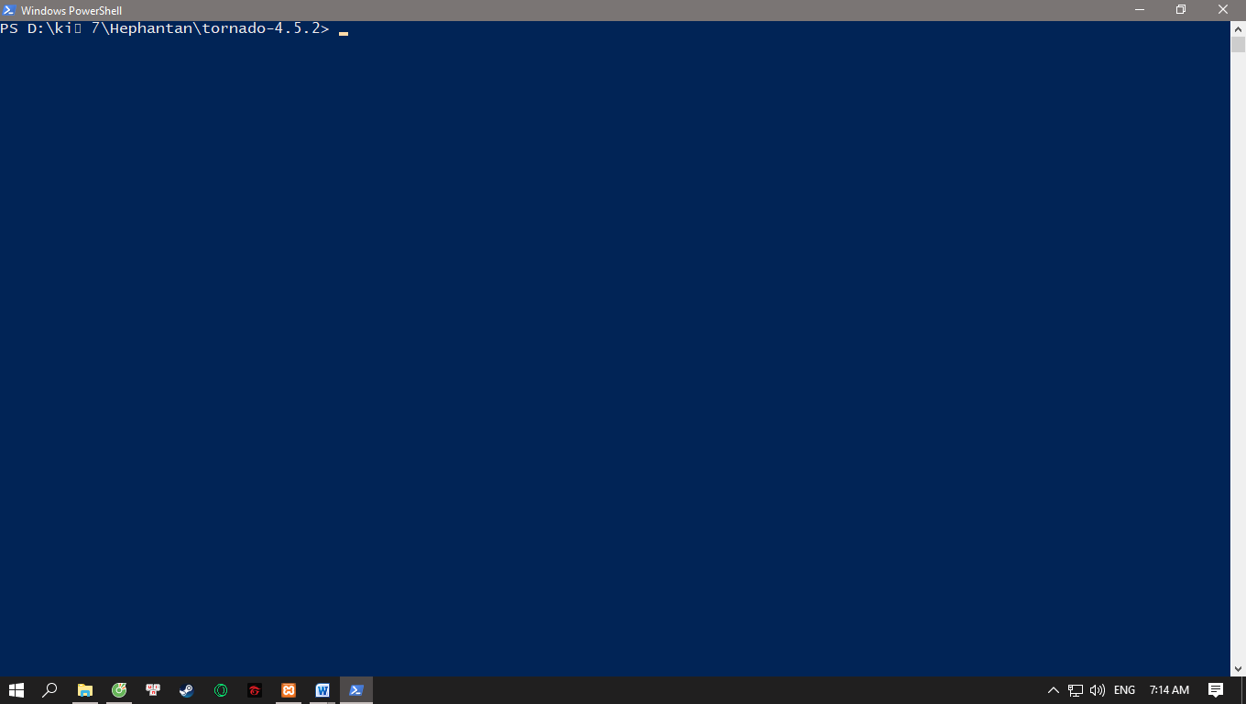

**Bước 1**. Chạy lệnh: **python setup.py install.**

**Bước 2:** Chờ đến khi hoàn thành xog

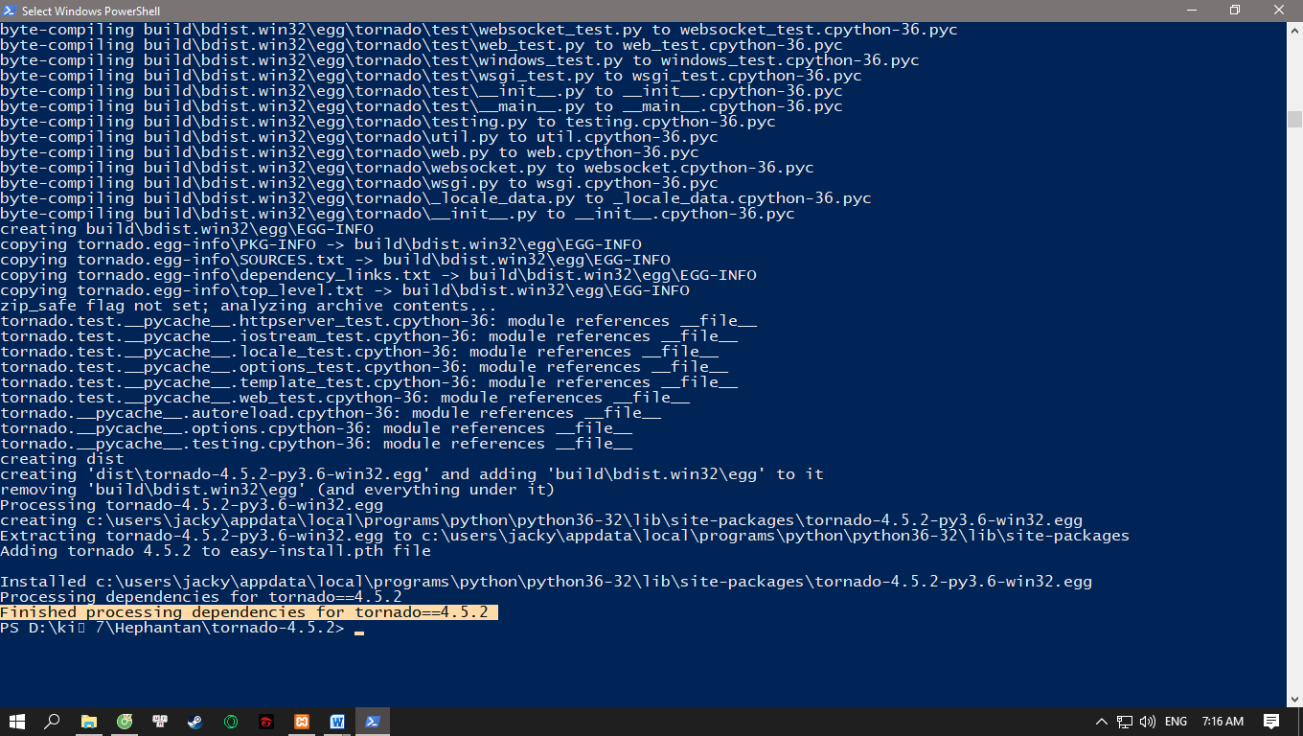

Chúng ta đã cài đặt xong tornado.

**Bước 3**: Tiến hành test Tornado

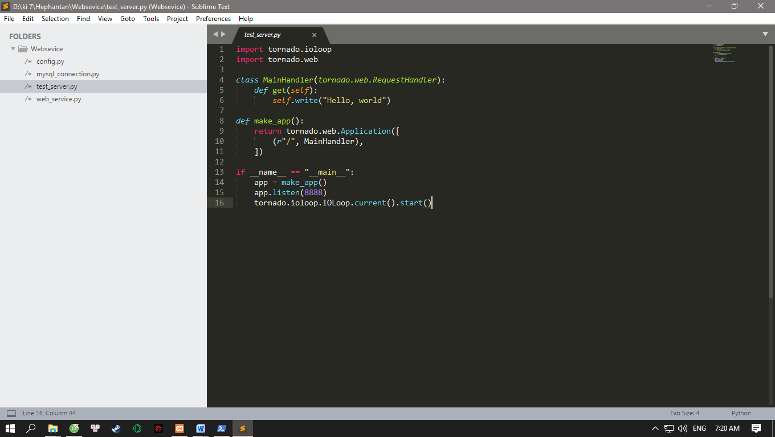

Nhập lệnh : python test_server.py

Sau đó chạy localhost: <http://localhost:8888/>

Kết quả:

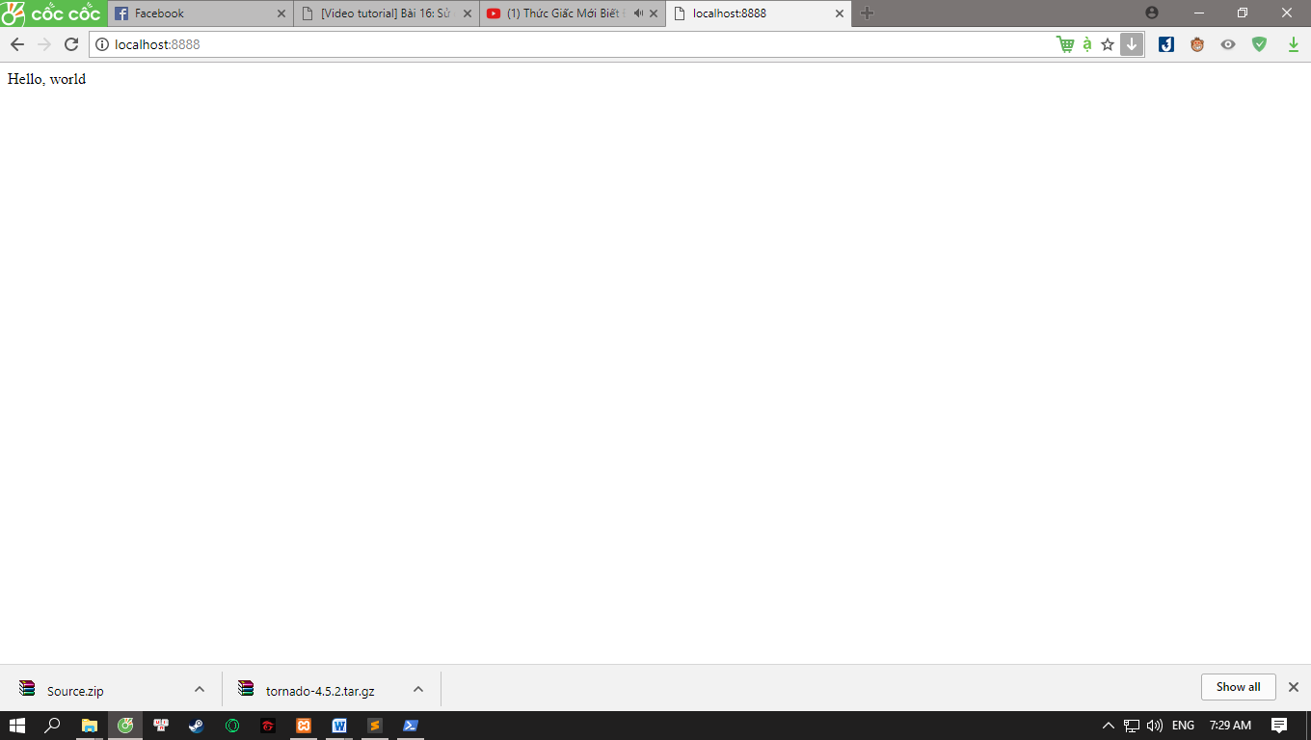

Chúng ta đã chạy thành công.

1. **Test Webservice**
2. **Tạo cơ sở dữ liệu**

Dùng Heidi(SQL) để tạo cơ sở dữ liệu

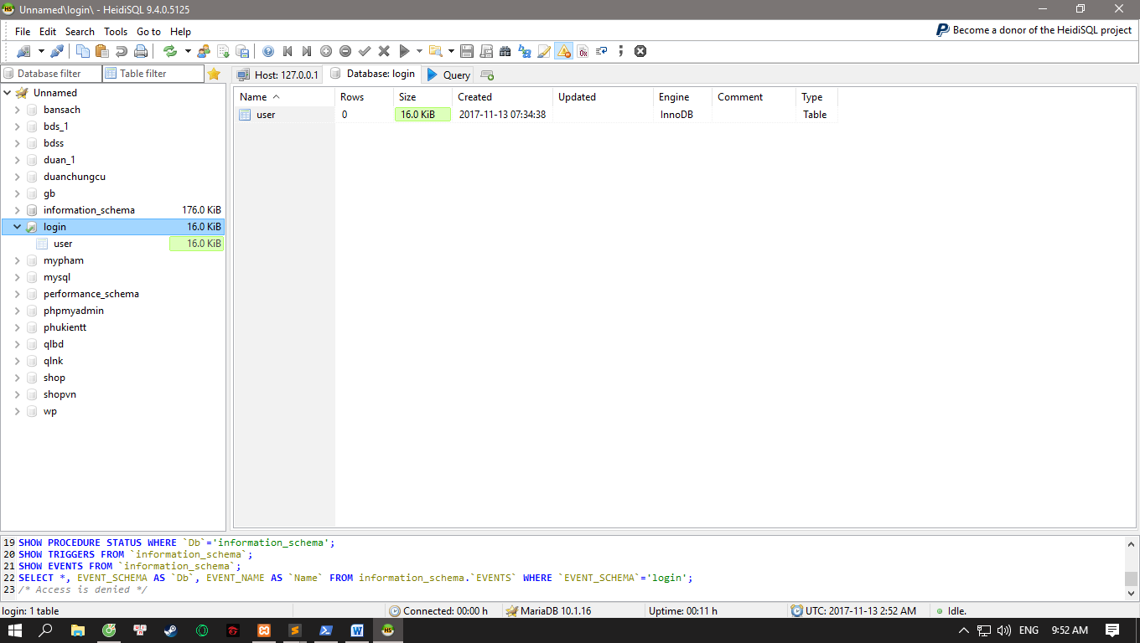

Gồm:

+Database: Login

+Table : user.

1. **Tạo File mysql_connection.py**

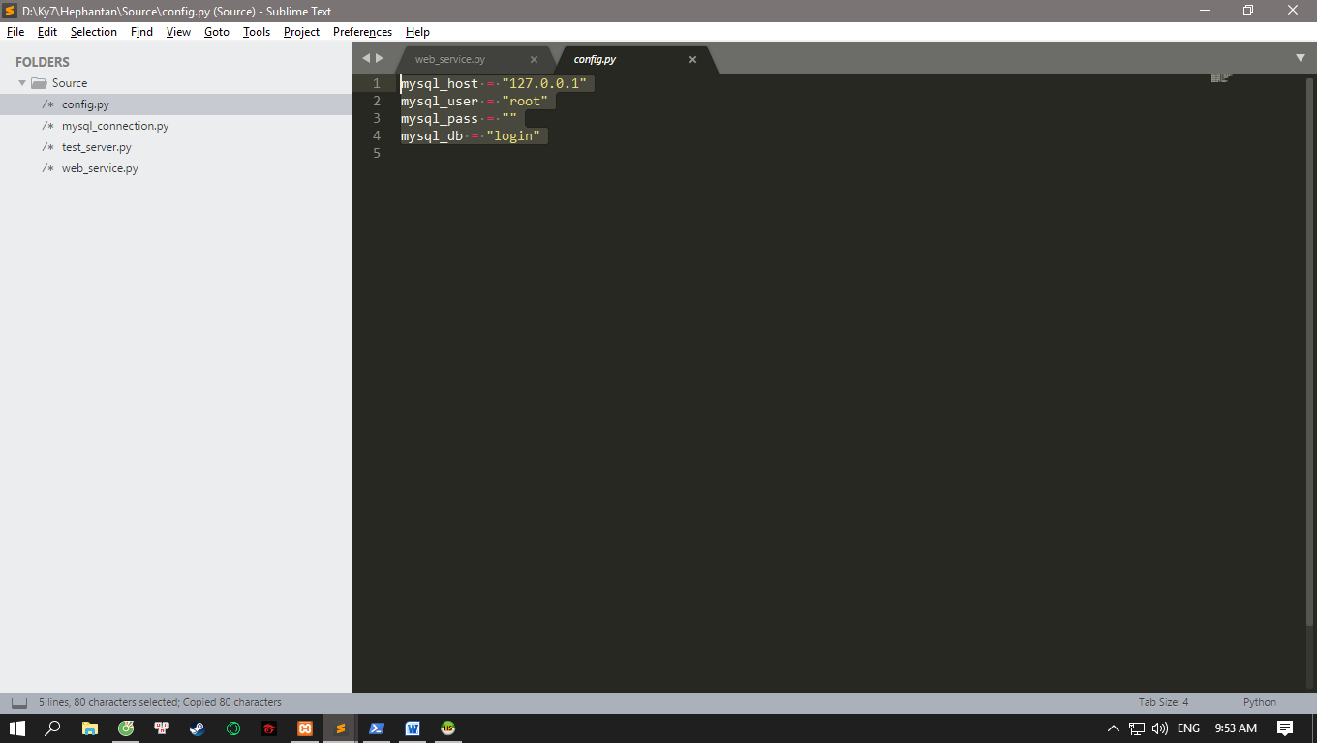

Khai báo hostname,username,password, databasename.

Sau đó, tạo file mysql_connection.py để kết nối với database

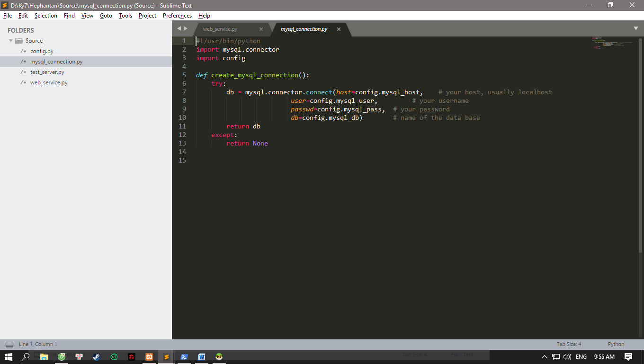

1. **Tạo file web_service.py để đưa dữ liệu về kiểu JSON**
2. **import** tornado.ioloop
3. **import** tornado.web
4. **import** mysql_connection
5. **import** json
7. **class** UserHandler(tornado.web.RequestHandler):
8. **def** get(self):
9. user_list = []
10. conn = mysql_connection.create_mysql_connection()
11. cur = conn.cursor()
12. cur.execute("SELECT * FROM user")
13. # print all the first cell of all the rows
14. **for** row **in** cur.fetchall():
15. user_item = {}
16. user_item["id"] = row[0]
17. user_item["username"] = row[1]
18. user_item["password"] = row[2]
19. user_item["status"]=row[3]
20. user_list.append(user_item)
21. conn.close()
22. self.write(json.dumps(user_list))
24. **class** MainHandler(tornado.web.RequestHandler):
25. **def** get(self):
26. self.write("Hello, world")
28. **def** make_app():
29. **return** tornado.web.Application([
30. (r"/", MainHandler),
31. (r"/users", UserHandler),
32. ])
34. **if** __name__ == "__main__":
35. app = make_app()
36. app.listen(8888)
37. tornado.ioloop.IOLoop.current().start()

Ở đây ta dùng    **self.write(json.dumps(user_list))**để đưa dữ liệu về kiểu JSon.

Thực thi lệnh

PS D:\Ky7\Hephantan\Source> python config.py

PS D:\Ky7\Hephantan\Source> python mysql_connection.py

PS D:\Ky7\Hephantan\Source> python web_service.py

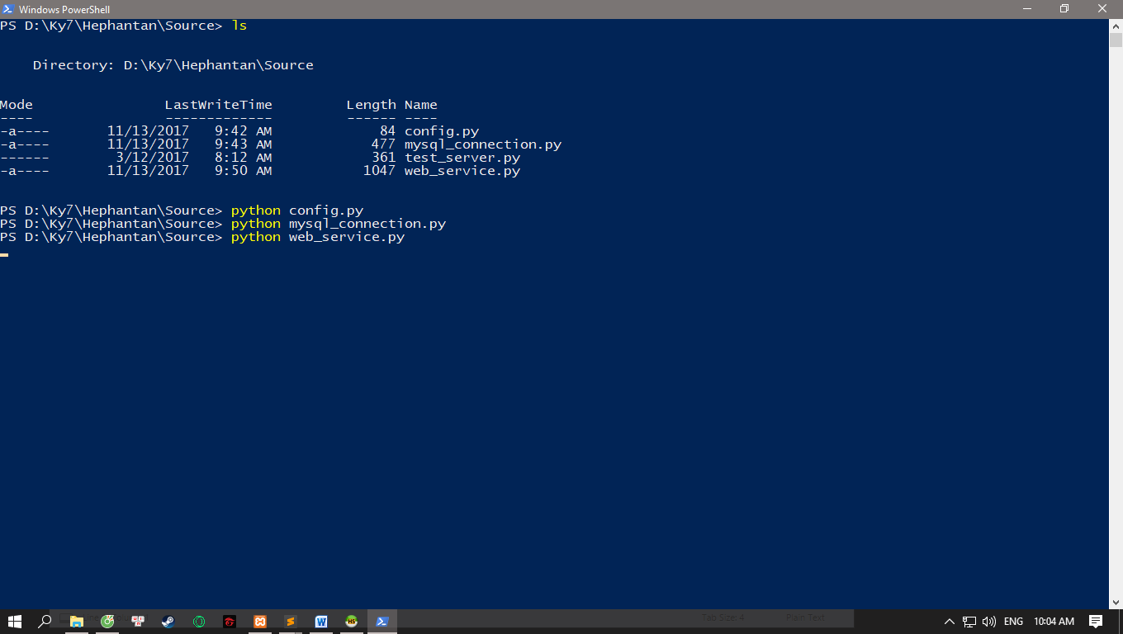

**Kết quả:**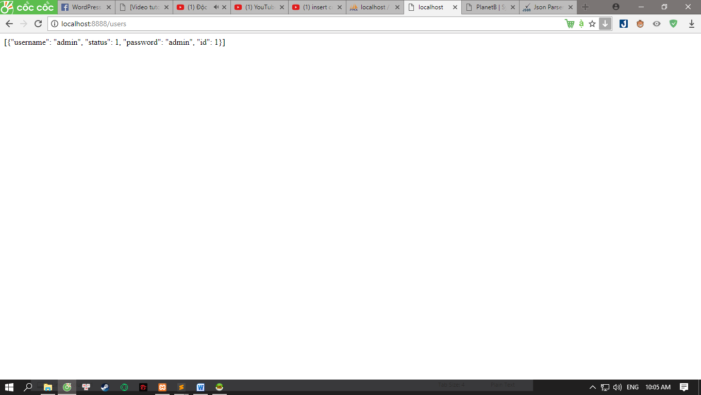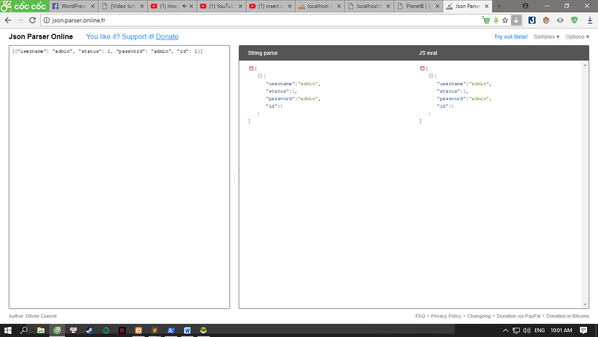

KẾT THÚC GIAI ĐOẠN 3.